Can I use weather reports to compare the climate in different countries?
Look at weather reports
BELIZE CITY, BELIZE, SOUTH AMERICA
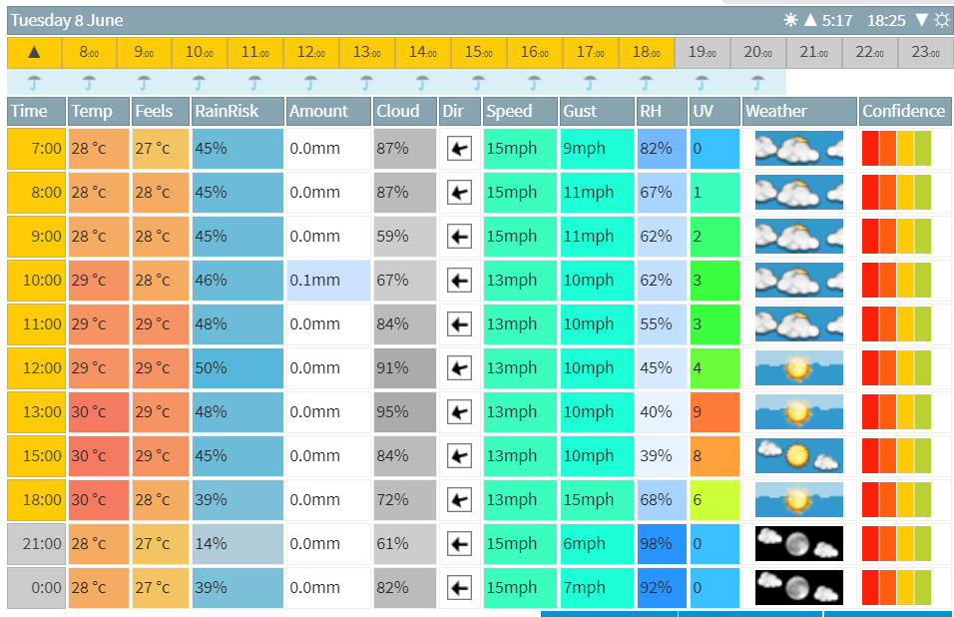
MIDDLEWICH, UNITED KINGDOM, EUROPE
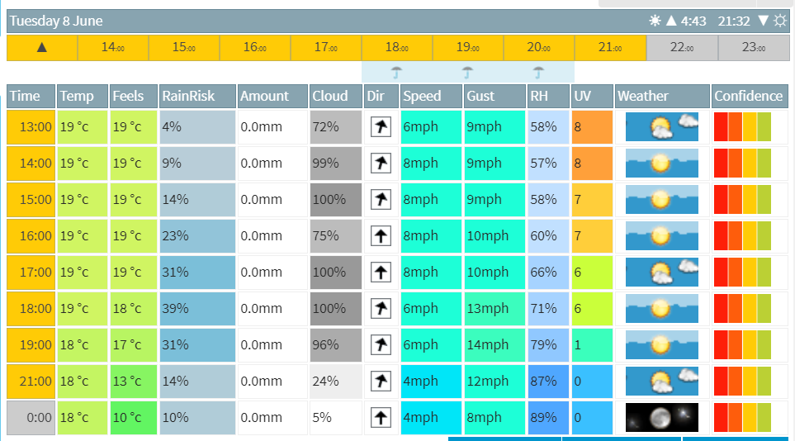

What is similar?

What is different?

Plot a line graph to compare temperatures between the two places

