

**Cledford Primary School and Gainsborough Primary & Nursery School**

A Federation of Cheshire East Primary Schools

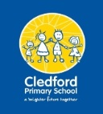

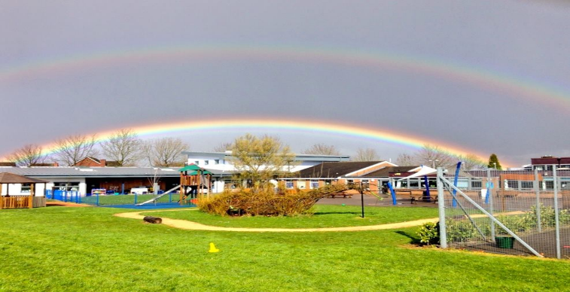 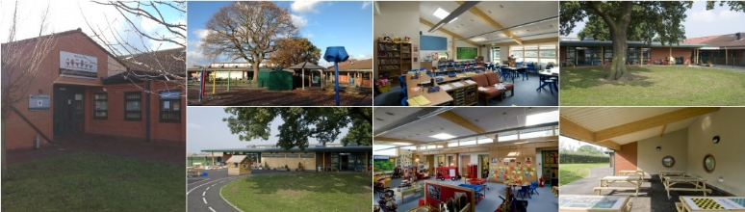

**Cledford Primary School**  **Gainsborough Primary & Nursery School**

George VI Avenue, Middlewich, Cheshire, CW10 0DD Belgrave Road, Crewe, Cheshire, CW2 7NH

Telephone: 01606 663667 Telephone: 01270 696810

E mail: admin@cledford.cheshire.sch.uk E mail: admin@gainsborough.cheshire.sch.uk

Website: www.cledford.cheshire.sch.uk Website: www.gainsboroughschool.co.uk

School Principal: Mr C Adlington Federation Headteacher: Mrs A J Booth School Principal: Mrs J Nurse

Friday 29th September 2023

Dear Parents/ Carers

Application to convert to Academy status and to join a Multi-Academy Trust (MAT)

Consultation Letter for Parents and Carers

As you know, Cledford Primary School has worked closely in a federation with Gainsborough Primary & Nursery school for 8 years. The federation has provided staff in both schools with excellent joint training, moderation and learning experiences which have made a positive impact on provision and achievement for our pupils; we are keen to continue and to enhance these opportunities.

The Governing Board’s priority continues to be to provide an excellent education for our pupils, whilst protecting our school’s ethos and identity, and retaining its individual qualities and strengths.

Local education authorities and their maintained schools have come under increasing financial pressures in recent years and attaining academy status will give both schools additional freedoms in access to and use of finances.

Cheshire East Local Authority no longer has the capacity to provide the kind of services and support that we have relied on in the past (access to an educational psychologist, for example) and we know the value of providing additional support services (such as speech and language therapy, for example) in school.

The current Government’s vision is for every school to be part of a wider family of schools in a MAT.

All these factors have led the governing board to consider applying to become an Academy and joining a Multi Academy Trust (MAT).

We have been working closely for some time now with the Alexandra Multi Academy Trust; staff have worked together to share best practice and each school has helped to monitor standards in the others. We are confident that joining this trust will bring many benefits for our children, the school and the wider community.

There are currently 2 schools in the Alexandra Multi Academy Trust:

Monks Coppenhall Academy & Day Nursery

and

Haslington Primary Academy & Nursery

The MAT would welcome the experience and expertise our staff would bring.

We would continue to maintain and develop our links with other local schools and organisations.

The Governing Board has therefore agreed to consult on applying for academy status and joining the Alexandra Multi Academy Trust. The earliest date this conversion could happen is 1st April 2024.

The consultation is open to everyone, including the school’s parents, pupils, staff and the wider community.

We want to hear your views, which the Governing Board will take into account when making its final decision. The consultation period will end on 27th October 2023.

There are some ‘frequently asked questions’ below. You can also email the school if you wish to communicate your questions or thoughts to us:

[admin@cledford.cheshire.sch.uk](mailto:admin@cledford.cheshire.sch.uk)

Our school is in a strong position to become an academy; we are confident that we have the vision, skills and resources to serve the best interests of our community and to shape our own destiny.

We are excited by the prospect of joining the Alexandra Multi Academy Trust because:

* we will be able to nurture and maintain our school’s individuality and unique identity
* the trust already has an excellent track record of school improvement (Monks Coppenhall is graded ‘outstanding’ by Ofsted)
* the trust recognises the strengths of our school and the excellent practice identified by ‘Ofsted’
* together, the 4 schools hope to offer significant additional support services for pupils and families as well as strong training, development and networking arrangements for staff
* we are confident that we can strengthen our financial position in a MAT

Frequently Asked Questions (FAQs)

**What is a MAT?**

A MAT is a group of schools that have agreed to join together for funding, governance and school improvement purposes

**Why are we proposing this?**

We believe that becoming an academy and joining the Alexandra Multi Academy Trust will help us to improve our school further

**What will stay the same?**

• Our school ethos and values;

• Our uniform

• Our staff and our staff terms, conditions and pensions

• Admissions

• The school will still have a Local Governing Board with parent and staff representatives

**What will be different?**

• Our funding will come directly from the government rather than through Cheshire East Council

• The MAT will have improved access to government grants (e.g. for building improvements) and we hope to make savings through the trust that can be directed towards pupil resources

* There will be greater support for school improvement; we are aiming for an ‘outstanding’ ‘Ofsted’ grade ourselves.

**Will the academy still be inspected by Ofsted?**

 • Yes, all academies are inspected by Ofsted using the same framework and timescales as maintained schools.

• The academies in the MAT will continue to be inspected separately; however, this may change in line with government policy.

• Ofsted will carry out inspections of the trust as whole.

**How are the children affected?**

In many ways the children will not notice any immediate difference, they will be in the same uniform, in the same classrooms with the same teaching staff. We will continue to strive for an outstanding education for all our children. However, in time the children may notice changes and improvements in the way that they learn, resulting from the greater training opportunities given to teaching staff to innovate and improve the pupils’ learning.

**Will we get more money as an Academy?**

Academies receive the same amount of per-pupil funding as they would receive from the Local Authority as a maintained school. All funding comes direct from Government to the Multi Academy Trust which, through individual school participation on the Board of Directors, then controls the overall budget. Each school does not necessarily have more money, but as a group the schools are better able to share the cost of resources.

**What are the risks of becoming an Academy?**

The change to Academy takes a school out of Local Authority control but does not exclude the school from Local Authority support. Local Authority support is provided equitably to maintained school and academies where a statutory duty applies. Other services are available on a traded basis for both maintained schools and academies to opt in as they wish. At some stage in the future, any school might be influenced to become part of a broader Academy Chain. We believe that the ability to join a local MAT, under local direction, offers the best opportunity to sustain vibrant, successful local schools and the best outcomes for children.

**How will parents be affected?**

• Parents will not be affected; however, they may start to see and hear more information about the MAT.

• Parents may notice that correspondence sent by the academy, e.g. letters and emails, will include the MAT’s logo.

The school is not obligated to become an academy and will only continue with the planned conversion to become an academy when parents and carers of pupils at the school, staff at the school, and the pupils themselves have had the opportunity to comment on whether the conversion should take place.

School governors will only move forward if they are sure that the conversion is in the best interests of our school and community.

I look forward to hearing your views



Jane Booth

Federation Headteacher