Were the Vikings always vicious and victorious?

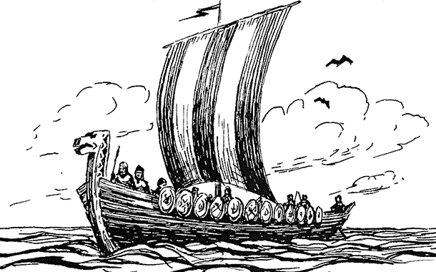

YEAR 6 Autumn 2020

Year 6 is always an extremely busy year filled with new opportunities and challenges. This year, more than ever before, we have a huge amount of content to cover. We have carefully planned an intensive recovery curriculum to help make up for lost learning time and hope to have lots of fun during our journey.

English
We will be grasping every opportunity we can to write in a variety of genres for a range of purposes including narratives, diaries, reports and explanations. Accurate and ambitious punctuation will be a focus of our learning as we endeavour to use and understand the full range of punctuation required for the end of Key Stage 2 expected standard. The improvement of proof-reading and editing skills will be vital this term as the children will be encouraged to take ownership of their writing by independently checking for spelling and grammatical errors, as well as improving the content by altering word choices and sentence structures for effect. Increasing our reading stamina is extremely important this term and these skills will be reinforced by making full use of quality texts right across the curriculum. We cannot stress enough the importance of daily reading at home as well as school to boost fluency and comprehension skills.

Maths
We are looking forward to using the ‘Power Maths’ scheme of work this year where there is an emphasis on curriculum mastery in our mathematicians. Children are expected to solve arithmetic problems involving the four operations with a high level fluency at the end of Key Stage 2 so we will be working every day to improve the efficiency of our work. Similarly, problem solving and the ability to apply mathematical knowledge to a range of problems is a key part of the expected standard and we will be pushing the children to apply their reasoning skills in a variety of contexts with increased independence. Of course, it is vital that children have a secure and swift recall of their times tables up to 12x12 as well as the related division facts. Please ensure that you work on these with your child every day to support our work in school.

Science
The workings of the human digestive system is our science focus at the beginning of this term. We will learn about the journey our food takes and the ways in which the human body extracts the essential nutrients from it. Our learning will be based around the story of ‘The Incredible Book Eating Boy’ by Oliver Jeffers. Later in the term, we will explore how light travels and then use diagrams and physical representations to explain how we see objects and how shadows are formed.

History
Our work in history will be based primarily around the Vikings as we investigate the accuracy of their notoriety for viciousness and victory in battle. We will find out about where the Vikings came from and some of their legacies.

Geography
We will use maps and atlases to locate the countries where the Vikings came from and look at the routes they took in their conquests. After half term, our learning will focus on the geography of South America, discovering the countries which comprise this area and some of their main physical features.

Music
We will be recording rhythm and notation using both formal and informal methods. We will follow rhythms, keeping time, before creating and transcribing our own rhythms and melodies for others to follow. Performance and appraisal is a key aspect of the music curriculum and we will consider what makes a performance successful and how we can emulate this in our own work.

Art and Design Technology
Linking to our history work investigating Viking long ships, we will be drawing and painting images of these incredible pieces of engineering after developing our sketching skills using techniques such as shading and cross-hatching. Also, we will create a three dimensional model of the human mouth to reinforce our science learning.

RE
We will be learning about the key features of Hinduism this term, including symbolism, reincarnation and forms of worship. The children will be encouraged to make links between their learning about this faith and others taught over their time in Key Stage 2. We will think about the beliefs which unite us and the differences that we must celebrate. Personal reflection and the importance of respecting the opinions of others will come to the fore in our RE learning.

PE
PE this term will focus on games and the skills required to play with strategy and fairness. Later in the term, we will develop gymnastic skills, considering effective ways to link shapes and movement. All children must have their full PE kit in school every day. Autumn term’s weather is always variable so both indoor and outdoor kit is required, please. Kit includes a white tshirt, blue shorts, blue joggers, black pumps and trainers. Long hair must be tied back and no jewellery is allowed.

French
Building upon our previous learning whilst extending our vocabulary, we will continue to hold simple conversations with at least four exchanges. Learning this term will centre on offering our opinions. We will begin to use the context of a conversation or piece of text to work out the meaning of unfamiliar words. This will support our inference skills in reading in English in addition to our growing knowledge of the French language.

Homework
Children are expected to read at least 5 times a week and have their reading record signed. Children are permitted to read independently and write their own comments. However, it is important that an adult at home listens to them read regularly and records this in their diary too. There will be a set day for swapping books in school each week so that we can ensure that they are safely quarantined before being returned to the shelves. The procedure will be explained in more detail in your child’s reading diary. We cannot stress enough the importance of daily reading to boost fluency and comprehension skills. National tests for the end of Key Stage 2 are extremely rigorous and children are expected to have a good reading stamina and extensive vocabulary. The only way to improve is to read, read and read again!

As part of both our recovery curriculum plans and the high school transition process, homework will take a more formal approach in year 6. A combination of reading, maths and spelling, punctuation and grammar (SPAG) homework will be set on a weekly basis for children. This will complement our work in school and help to reinforce taught skills. Year 6 is a jam-packed year ordinarily but as we have more than ever to cover this year, weekly homework will be an essential tool for consolidating the learning in school.

Weekly spelling tests will also continue in year 6. Just five minutes of revision each night has a noticeable impact upon the quality and accuracy of writing.

We will make every effort to utilise the year 6 area of the school website considerably this year as we plan to routinely share examples of calculation methods for maths, as well as grammar and punctuation concepts in English. We hope that this will not only be useful for reminding the children of the work we complete in school, but also for explaining the children’s learning to family at home. It has been such a vital tool in recent times that we are keen to use it further in the coming year.

At times it may be appropriate for children to be given additional homework tasks to support and reinforce their learning in school. Parents will be kept fully informed of any additional homework requirements as the term progresses. We really do appreciate your ongoing support and the children most certainly reap the benefits when we all work together.

Online homework resources will continue this year with Times Table Rockstars and Purple Mash. Login information will be provided in your child’s reading diary.

We are very much looking forward to the term ahead, which will no doubt be challenging and exciting in equal measure! As always, if you wish to discuss anything further then please don’t hesitate to speak to a member of the year 6 team.

Kind regards

Miss Wagstaff, Miss Platt, Mrs Hassall and Mrs Falconbridge
The Year 6 team

