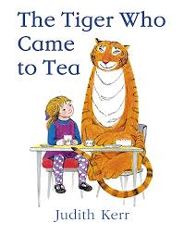
Year 1 Autumn 2019
Are iPads more fun than my grandparent’s toys?
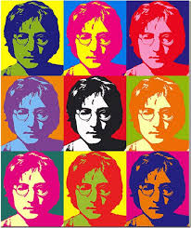
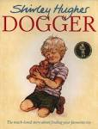
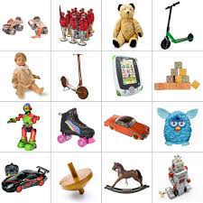

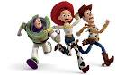

We have a busy term ahead of us as we explore our exciting topic. We will learn about the past during the 1960s and compare it to our lives today. We will be exploring how toys, schools, games, music, fashion and TV programs have changed over time.

English
We will be exploring both classic and modern stories such as ‘The Tiger who came to tea’, ‘Where the wild things are’ and ‘On sudden hill’ where we will be developing our skills of retelling stories using adjectives and time words such as ‘First’, ‘Next’ and ‘Finally’. One of the more modern stories we will be reading is called ‘Whatever Next’ by Jill Murphy where we will be going on adventure to the moon with Baby Bear! We will be writing in different styles such as character descriptions, instructions and letters. We will also be working hard to extend our sentences with conjunctions such as 'and' and ‘but’ as well as starting to practise our cursive handwriting. We look forward to getting the children excited about their writing!

Maths
This term we will be focussing on developing number knowledge within 20. We will be sorting and counting objects, finding one more and one less and comparing numbers. We will learn to read and write numbers to 20 in numerals and words. We will be solving mathematical problems that involve addition and subtraction and using number bonds and related subtraction facts within 20. In geometry we will explore 2D and 3D shapes, sorting, naming and looking at patterns.

Science
We will be looking at grouping and classifying a range of both natural and man-made materials and we will apply our knowledge to help solve problems such as finding the best material for Baby Bear’s coat! We will also look at what happens to the animals and plants around us as the seasons change. We will label different parts of our body and learn about our different senses.

Humanities
In geography we will be observing the weather and learning how to keep a weather chart. We will look at how the weather changes throughout the year in the UK and the four seasons. In history, we look forward to exploring how toys have changed since the 1960s and comparing games from then and now. We will also be learning about significant events such as the first moon landing.

Music
We will be singing the popular Beatles classic ‘Yellow Submarine’ and learning how to clap in time to a beat. We will also use percussion instruments and actions to improve our performance. We explore different types of music and express our likes and dislikes.

Religious Education
In RE this term we will be exploring how to be a good citizen and take care of the world around us. We will be exploring different stories from the bible and thinking about the importance of giving at Harvest time. We will share the Nativity story, learning all about the gifts Jesus was given.

Art and Design and Technology
We will look at the work of a famous 1960s pop artist, Andy Warhol, focussing on his prints of toys for children and have a go at printing in his style. In D&T we will design and make our own moving toys. We will develop our cutting and sticking skills.

Physical Education
In PE sessions we will be investigating different ways of moving and balancing and thinking about how to work together in teams. We will also be learning some dance moves from the 1960s. Please ensure that your child has a fully labelled PE kit with them in school at all times.

Dates for the diary

Wow Day – The Swinging 60s Thursday 22nd October (More information to follow)

We are very much looking forward to the term ahead and would like to thank you once again for your support.

Kind regards

The Year 1 Team

