

**Cledford Primary School and Gainsborough Primary & Nursery School**

A Federation of Cheshire East Primary Schools

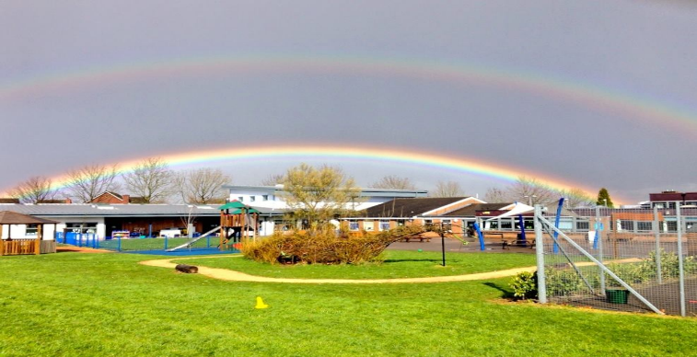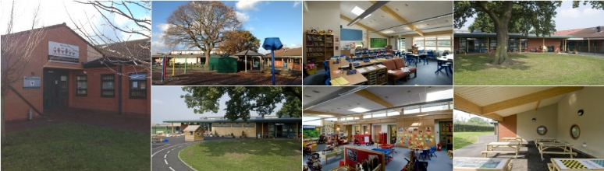

**Cledford Primary School**  **Gainsborough Primary & Nursery School**

George VI Avenue, Middlewich, Cheshire, CW10 0DD Belgrave Road, Crewe, Cheshire, CW2 7NH

Telephone: 01606 663667 Telephone: 01270 696810

E mail: admin@cledford.cheshire.sch.uk E mail: admin@gainsborough.cheshire.sch.uk

Website: www.cledford.cheshire.sch.uk Website: www.gainsboroughschool.co.uk

Local Authority Code: 895 Local Authority Code: 895

Establishment Number: 3821 Establishment Number: 3810

School Principal: Mr C Adlington Federation Headteacher: Mrs A J Booth School Principal: Mrs J Nurse

**Federation Charging and Remissions Policy**

**Reviewed: November 2022**

**Signed:**

**Mrs J Sercombe** (Chair of Governing Board) ……………………………………………………………………………….

**Mrs AJ Booth** (Federation Headteacher) …………………………………………………………………………………….

**Mrs J Nurse** (School Principal GPNS) …………………………………………………………………………………………..

**Mr C Adlington** (School Principal CPS) .................................................................................................

Next Review Date: September 2023

**INTRODUCTION**

The Federation Headteacher and Federation Governing Board recognise the value of providing a wide range of experiences to enrich and extend pupils’ learning and to contribute to their personal development. The Federation Headteacher and Federation Governing Board aim to promote and provide such experiences for the pupils of the federation, as part of a broad and balanced curriculum.

Many of these activities have an associated cost and cannot be provided unless voluntary contributions are received or parents are charged for the cost.

This policy sets out the circumstances in which charges will or will not be made for school activities and when charges may be waived in order to ensure that all pupils have an equal opportunity to benefit from educational visits, curricular and extra-curricular activities.

**STATEMENT**

The policy complies with the requirements of the Education Act 1996

Where ‘parent’ is referred to this will include adults with a responsibility for the pupil. We aim:-

* To make school activities accessible to all pupils regardless of family income
* To encourage and promote external activities which give added value to the curriculum
* To provide a process which allows activities to take place at a minimum cost to parents, pupils and the school/s
* To respond to the wide variations in family income while not adding additional unexpected burdens to the school budget.

**LEGISLATION – EDUCATIONAL DURING SCHOOL HOURS**

The DfE in its guidance to School Governors states that “education provided during school hours must be free. The definition of “education” includes materials, equipment and transport provided in school hours by school to carry pupils between the school and an activity.” It goes on to advise that “although schools cannot charge for school time activities, they may still invite parents and others to make voluntary contributions.”

When additional costs are incurred by the federation to enhance the curriculum opportunities for the pupils, parents may be requested to make voluntary contributions. However, no pupil will be left out of an activity because his or her parents cannot or will not make a contribution of any kind.

**EDUCATION OUTSIDE SCHOOL HOURS**

The DfE in its guidance to School Governors states that “Parents can only be charged for activities that happen outside school hours when these activities are not a necessary part of the national curriculum or religious education. No charge can be made for activities that are an essential part of the syllabus for an approved examination. Charges may be made for other activities that happen outside school hours if parents agree to pay. The Education Reform Act 1988 described activities, which can be charged for as “optional extras”.

**REMISSIONS**

To ensure that access to activities reflect intentions the federation will implement the following Remissions Policy. The fundamental aim of this policy is to ensure that all pupils gain fully from everything that the federation is able to offer them and is based on an understanding of the relationship between low income, entitlement and access. This policy takes into account the difficulties which people on low income have in meeting the costs of educational activities for their children.

Where parents are in receipt of Universal Credit or Child Tax Credit (as long as Working Tax Credit is not also received), the Federation Governing Board may observe its statutory requirement to remit in full or in part the cost of board and lodgings for a residential activity that the school organized for the pupil if the activity is deemed to take place within school hours.

There may be cases of family hardship which make it difficult for parents to make a contribution for particular activities. When arranging a chargeable activity the Federation Governing Board will invite parents to apply in confidence for the remission of charges in part or in full. Authorisation of remission will be made by the Federation Headteacher/Principal in consultation with the Chair of Governors.

**Data Protection of pupils and families**

Teachers will ensure that these children are not publicly identified. This is particularly important as the fear of stigmatization is often a key element in the non-take up of Free School Meals.

**CONTRIBUTIONS**

Voluntary contributions may be requested to help with providing activities even though they may be part of the normal school day or part of the National Curriculum.

If voluntary contributions are requested for an activity it should be clearly understood that there is no obligation to contribute and that if the parent is unable or unwilling to pay, the child will not be excluded from the activity.

**If sufficient contributions are not received the activity may be cancelled.**

**CHARGES**

The Federation Governing Board reserves the right to make a charge for the activities and items detailed below:

Visits which are not part of the school curriculum or are outside of the school day (i.e. weekend residential)

After/pre-school clubs

Music tuition if it is not required for the National Curriculum and is provided for an individual pupil or for groups of pupils

Damage to school property – the cost of replacing any item, e.g. broken window, lost books,

* Visits to school by professionals e.g. authors, storytellers, musicians, dancers, artists etc.

The Federation Governing Board may amend the categories of activity for which a charge may be made.

Nothing in this policy statement precludes the Federation Governing Board from inviting parents to make a voluntary contribution towards the cost of providing education for pupils.

**Charging for Early Years Childcare.**

Gainsborough provides free places in our Nursery for children aged 3 for 15 or 30 hours per week dependent on parents’ eligibility. Top-Up Nursery provision is also offered chargeable to parents at a cost of £12 per session to pupils who already attend the Nursery.

**Before and After School and Holiday Club.**

Gainsborough offer Before and After School and Holiday Club provision to parents for pupils attending our school. Requests for places are made via the club manager and are paid for prior to the pupil attending the club. Costs can be found on the school website or by contacting the club manager/school office.

**OTHER OUTSIDE PROVIDER CHARGES.**

Charges will be made for the use of the schools’ premises. We work to a sliding scale and the charges are largely dependent on the nature of the provider and are determined on an individual case basis by the Finance, Resources and Personnel Committee and agreed by the Full Federation Governing Board.